Within the main results, there are a few tables that are the primary results. From the first paragraph of the paper, the authors mention the most important things they are analyzing: “Economic growth requires a sectoral reallocation of labor, yet various factors may keep workers in rural agriculture” and “low-wage agricultural labor may discourage labor-saving technological innovation or the adoption of new capital-intensive technologies”. In Table 2, the authors analyze the sectoral reallocation of labor, and in Tables 3-4, the authors analyze technological innovation. Since I consider all three of these tables equally important, I elect only to replicate Table 4 (within the code on the GitHub, all tables and graphs can be replicated, however) since I believe the results pertaining capital change are more interesting than labor movement, and because Table 4 captures more of the change in capital stock than Table 3. The empirical framework to analyze this is fairly simple: a fixed effect panel data regression. The occurrence of the flood at a county c and at time period t is the treatment variable, with fixed effects for county and state and time, and the specific capital stock being the predicted variable. The table replicated is below:
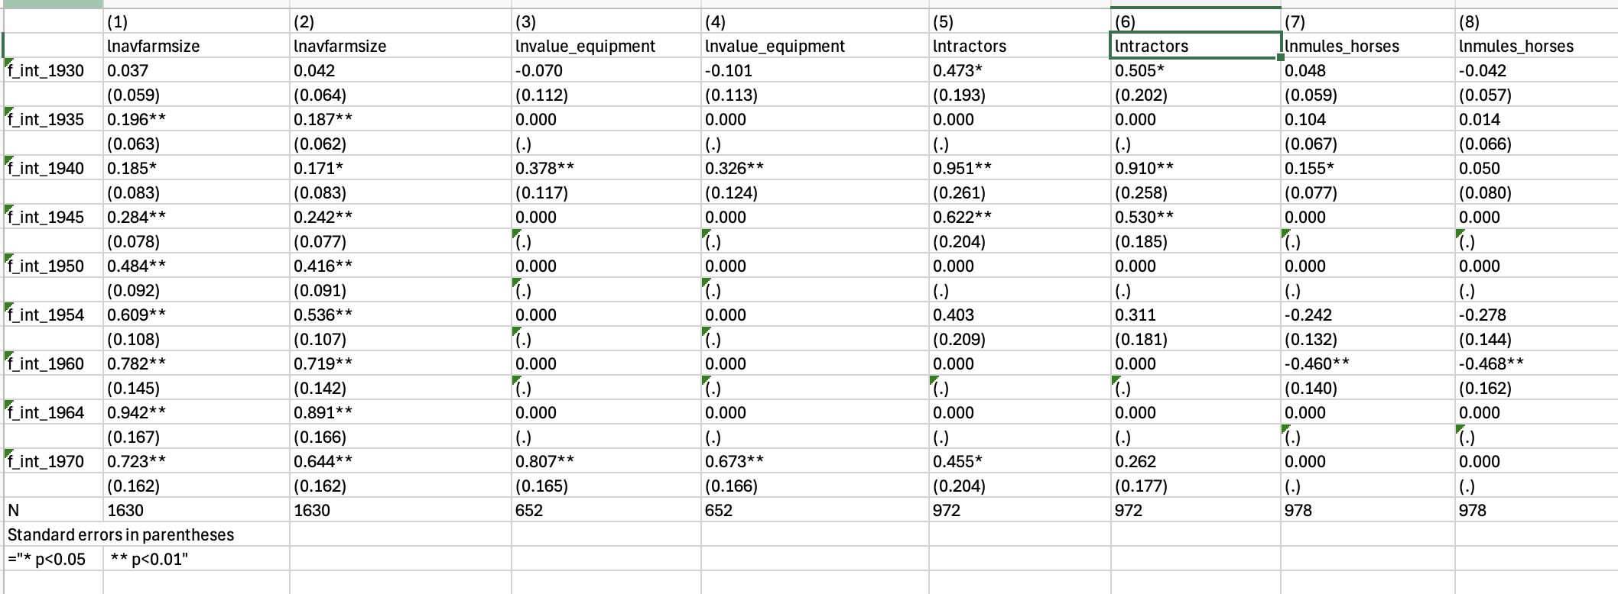
This can be obtained by running the Table_4_generation.do file with the preanalysis_post1930.dta file in the same location. Note first that it is in a csv format and that the columns in this output are different than in the paper, i.e. columns 1-2 in the paper are 3-4 here, 3-4 in the paper are 5-6 here, 5-6 in the paper are 7-8 here, and 7-8 in the paper are 1-2 here. Otherwise, the results are the exact same, replacing the 0.000 values with empty sections in the table.

